**DATA PREPROCESSING AND ANALYSIS FOR DATASET**

**Open Weka**

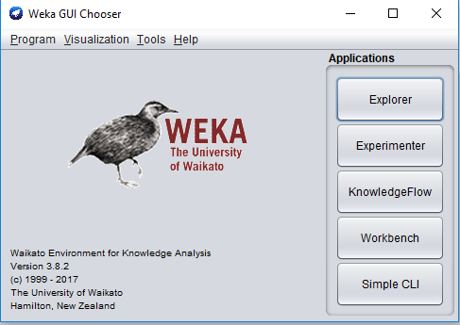

PREPROCESS :

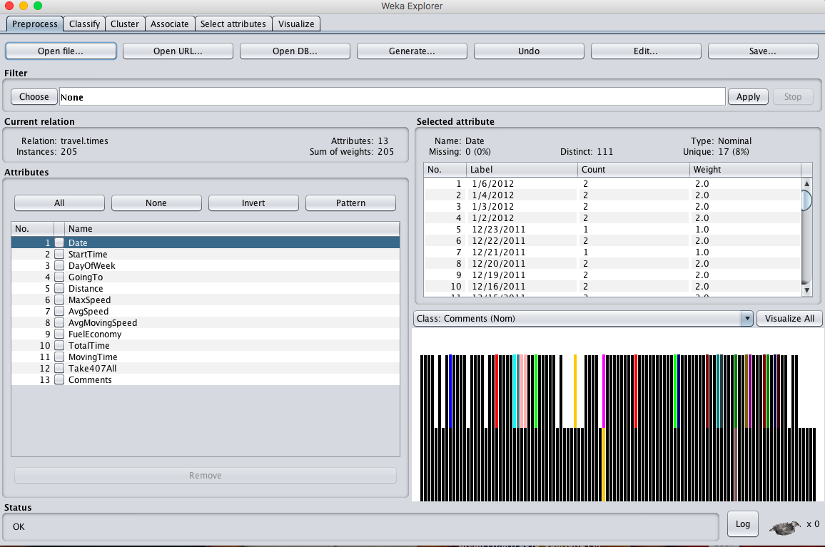

**MIN, MAX, MEAN, STANDARD DEVIATION :**

